5. Create a simple cloud software application for Library book reservation system for SIMATS
library using any Cloud Service Provider to demonstrate SaaS.
Aim
To create and deploy a simple cloud-based Library Book Reservation System for the SIMATS Library using Zoho Creator, in order to demonstrate Software as a Service (SaaS).

Procedure
- A Zoho Creator account was created and a new application for the Library Book Reservation System was developed.
- Forms were designed to collect student details such as name, register number, department, and contact information.
- Book details including book title, author, ISBN, and availability status were added to the system.
- A reservation form was created to allow users to select and reserve available books.
- Workflows and validations were configured to update book availability after reservation.
- Reports were generated to view reserved books, available books, and user details.
- The application was deployed on the Zoho Creator cloud platform and shared through a web URL for user access.
Output
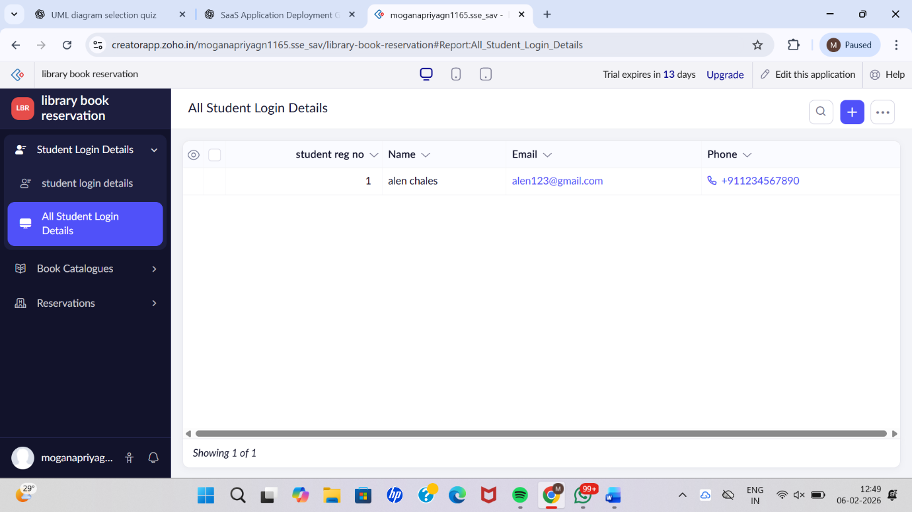

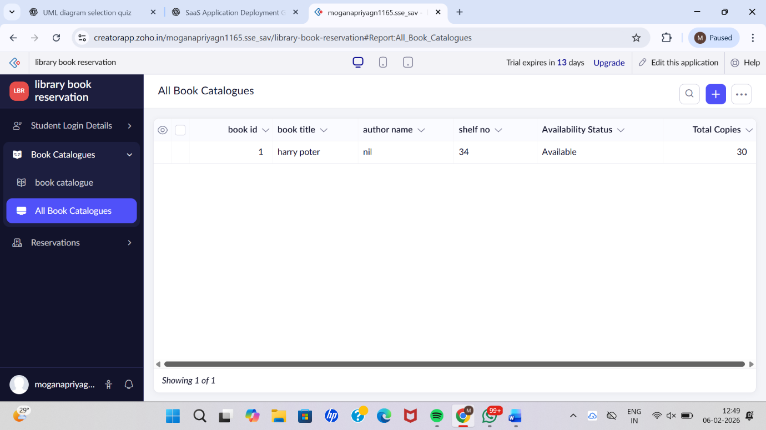

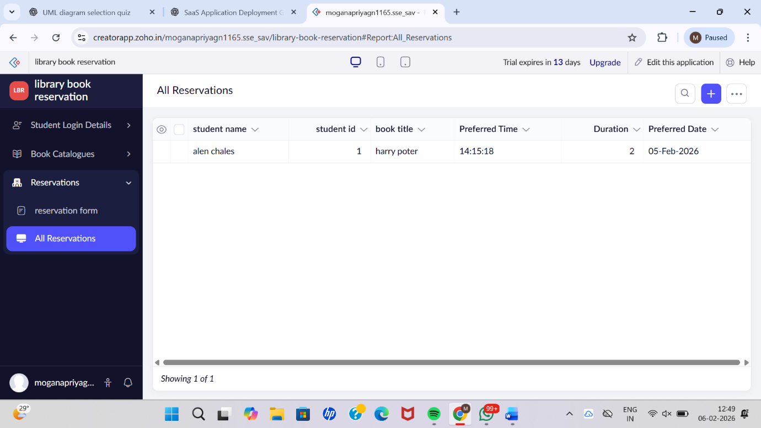

Result
Thus, a simple cloud-based Library Book Reservation System for the SIMATS Library was successfully created and deployed using Zoho Creator. The application was delivered as Software as a Service (SaaS), allowing users to reserve library books online through the internet without installing any software locally.

